世界中医药学会联合会肿瘤经方治疗研究专业委员会
Classical TCM Formula for Cancer Treatment and Research Committee of World Federation of Chinese Medicine Societies (WFCMS)
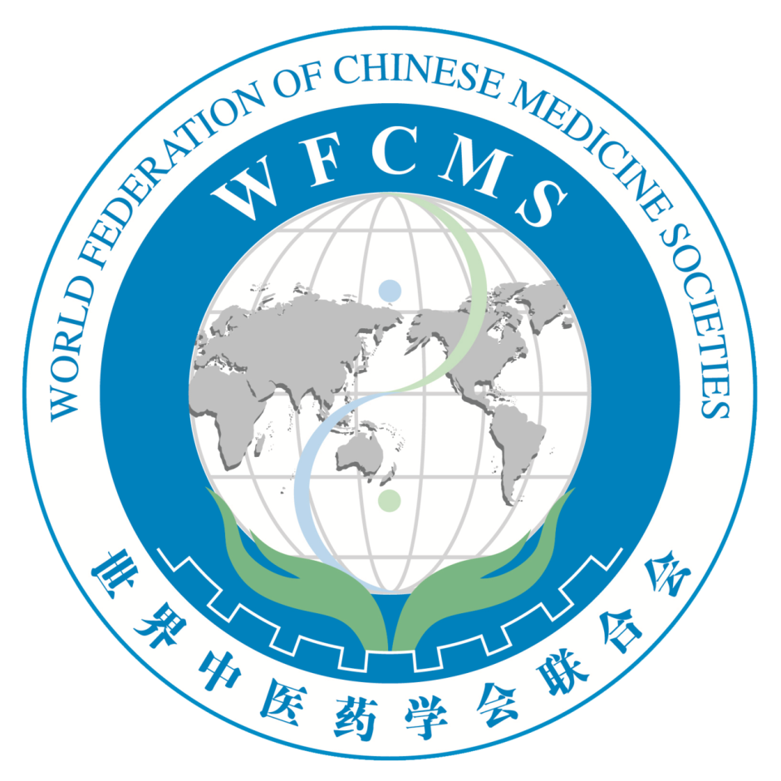
一、分支机构名称及发展领域界定：
本专业委员会以经方在肿瘤治疗中的应用为核心定位，挖掘、整理经方在肿瘤治疗中有效的验案，总结、梳理肿瘤经过放疗、化疗、分子靶向治疗及微创治疗等新的方法治疗后，出现的不同并发症的经方治疗方法，按照国际标准建立学科模式，围绕肿瘤及并发症的经方治疗，建立多专业一体化交叉学科优势平台，丰富肿瘤治疗的经方内涵，开发在中医经典理论指导下有效的肿瘤经方治疗药物，建立促进肿瘤治疗学科发展的专业委员会。
二、学术活动：
围绕肿瘤疾病及相关并发症的经方应用，每年召开一次学术年会，吸引多学科人员深入探讨，学科交叉融合，思维碰撞，展示经方治疗肿瘤及并发症的诊治成果及优势。将学科向纵深发展，推动国家相关政策的建立。
三、学科发展方向：
以发挥中医特色、发掘经方疗法、提高肿瘤及并发症的临床疗效为目标和学科发展方向。使肿瘤经方治疗经过不断交叉融合形成稳定的新学科。
四、分支机构的需求分析及预测规模：
在中医学的传承过程中，历史已无数次的证明，中医学中的任何一个分支学科的发展、成长都必须根植于中医经典理论肥沃的土壤，才能根深叶茂，否则将成为无源之水，无根之苗，那么如何使中医经典理论与中医肿瘤学更好的融合，发挥四大经典对中医肿瘤治疗的指导作用，成为中医肿瘤学发展的迫切需求。
人员构成主要为全国中医院肿瘤科医务人员、西医院中医科工作人员、全国高校从事经方研究的学者、全国基层社区医生、港、澳、台以及其它国家从事中医药治疗的医务人员。将以国家中医药管理局三批全国优秀临床人才班的1000名学员，港、澳、台以及其他国家的中医药学会负责人为骨干，开展专业委员会的建设，基本规模为常委300人左右，委员1000人左右，并逐步进行规范化建设，不断扩大在海内外的影响力。
五、委员会的负责人及依托单位情况：
世界中医药学会联合会肿瘤经方治疗专业委员会筹委会负责人为冯利教授，冯利教授有较高的学术影响力，目前担任：中国中医科学院望京医院肿瘤科主任，主任医师，北京中医药大学聘任教授，中国中医科学院及北京中医药大学博士研究生导师，博士后合作导师，国家中医药管理局“第三批全国优秀中医临床人才”，主编的《简明中西医结合肿瘤病学》2010年获中华中医药学会学术著作一等奖。具备担任世界中医药学会联合会肿瘤经方治疗专业委员会筹委会负责人的能力。
冯利教授所在的中国中医科学院望京医院为国家中医药管理局直属的三级甲等医院，所负责的肿瘤科是国家中医药管理局“十二五”中医肿瘤重点专科，国家中医药管理局“十二五”中西医结合临床重点学科，卫生部第一批癌痛规范化治疗示范病房培育单位，肿瘤科目前开放病床49张，病房面积1600平方米，病房条件、设施、配备，在北京市肿瘤学科领域处于前列。年门诊量约2.5万人次，出院患者700余人次。具备世界中医药学会联合会肿瘤经方治疗专业委员会会议筹备及示范参观基地的条件。

Classical TCM Formula for Cancer Treatment and Research Committee of World Federation of Chinese Medicine Societies (WFCMS)

1. Defining the Title of the Branch and the Development Area:
The professional committee, with the application of classical prescriptions in the treatment of tumor as the core location, aims at mining and sorting effective cases of classical prescriptions in the treatment of tumor, and summarizing and collecting the classical-prescription-based treatment methods in different complications after new treatments of tumor, such as radiotherapy, chemotherapy, molecular targeted therapy and minimally invasive treatment methods; and, according to the international standard and based on the classical-prescription-based treatment of tumor and related complications, aims at establishing the subject mode and the multi-professional integrated cross disciplinary advantage platform, to enrich the connotation of the classical prescriptions in tumor treatment, to develop classical effective Chinese formulas in the tumor treatment under the guidance of the classical Chinese medicine theory of classical prescription, and to establish the professional committee to promote the development of the tumor treatment subject.
2. Academic Activities:
Focusing on the application of classical prescriptions in treatment of tumor and related complications, the professional committee will convene an academic annual meeting once every year, to attract multi-disciplinary staff to participate in-depth studies, cross discipline integrations, thinking collisions, and displaying of results and advantages of tumor diagnosis and treatment of tumor and related complications by classical prescriptions. The professional committee will also promote this subject to the depth development, and further promote the establishment of related national policies.
3. The Development Direction of the Subject:
The professional committee takes Chinese characteristics expression, the classical-prescription based therapy exploration, and the clinical efficacy improvement of tumor and related complications treatment as its goals and the developing directions of the subject, and, by continuous cross fusion of classical-prescription-based tumor therapy, forms this stable new subject.
4. Analysis of embranchment demand and forecast of scale:
During the process of inheritance of traditional Chinese medicine(TCM), history has proved in numerous times that the development of any branch subject of traditional Chinese medicine must be rooted in the fertile soil of the classic theories of TCM to grow deep roots and luxuriant leaves, otherwise it will become sourceless water or rootless seedling. So how to make the fusion of classic theories of TCM and TCM oncology better, and how to play a guiding role of the four TCM classic works in tumor treatment better, have become the urgent demand of the development of TCM oncology.
The personnel is mainly constituted nationally by the medical personnel of oncology department of the national traditional Chinese medicine hospitals, traditional Chinese medicine staff in west medicine hospitals, national university scholars, and the national primary community physicians, including in Hong Kong, Macao, and Taiwan, and internationally by medical personnel of other countries engaged in traditional Chinese medicine in the treatment of tumor. The professional committee will take the 1000 students of the third batch of national excellent talent clinical class by State Administration of traditional Chinese medicine, and Persons-in-charge of the association of Chinese medicine in Hong Kong, Macao, Taiwan and other countries as the backbone, to carry out the construction of professional committee. The basic scale will be about 300 people as the Standing Committee, 1000 people as members, and with gradually standardized construction, the committee will expand its influence both at home and abroad.
5. the Person-in-charge and the Relying Unit of the Committee:
Professor Feng Li is the Person-in-charge of the Preparatory Committee for the Classical TCM Formula for Cancer Treatment and Research Committee of World Federation of Chinese Medicine Societies (WFCMS). Professor Feng Li has higher academic influence, and is currently serving as the director and chief physician of Department of oncology, in Wangjing Hospital of China Academy of Chinese medical Sciences(CACMS); as Professor in Beijing University of Chinese Medicine(BUCM); as doctoral tutor and postdoctoral cooperation tutor in both CACMS and BUCM; and as "the excellent clinical Chinese medicine talent" hornored in the third-batch by the State Administration of traditional Chinese medicine; as the editor of the work, namely, "Concise Integrated Oncology of Traditional Chinese and Western Medicine",which winned the 1st academic book prize in 2010 by China Association of traditional Chinese medicine. He has the ability to be the Person-in-charge of the Preparatory Committee for the Classical TCM Formula for Cancer Treatment and Research Committee of World Federation of Chinese Medicine Societies (WFCMS).
Wangjing Hospital of China Academy of Chinese medical Sciences(CACMS), where professor Feng Li is serving, is a third-level first-class hospital, affliated to the State Administration of traditional Chinese medicine. The department of tumor, which is incharged by professor Feng Li, is both the “key specialty of traditional Chinese medicine tumor” and the “integrated medical clinical key discipline” hornored by the State Administration of traditional Chinese medicine during the national “Twelfth Five Year Plan”, and the “standardized treatment of cancer pain demonstration and training unit” first-batchly hornored by the Ministry of health.Now, the tumor department has 49 open beds, a ward area of 1600 square meters, the ward conditions, facilities, and equipment are at the forefront in the oncology field in Beijing city. Annual outpatient amount are about 25000 persons, and can annually discharge patients of more than 700. We have both the preparatory and the demonstration visit base condition for Classical TCM Formula for Cancer Treatment and Research Committee of World Federation of Chinese Medicine Societies (WFCMS).

Communication:
冯利Feng Li：E-mail：fengli663@126.com ;
WeChat number：fengli_663 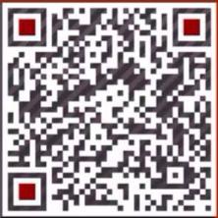
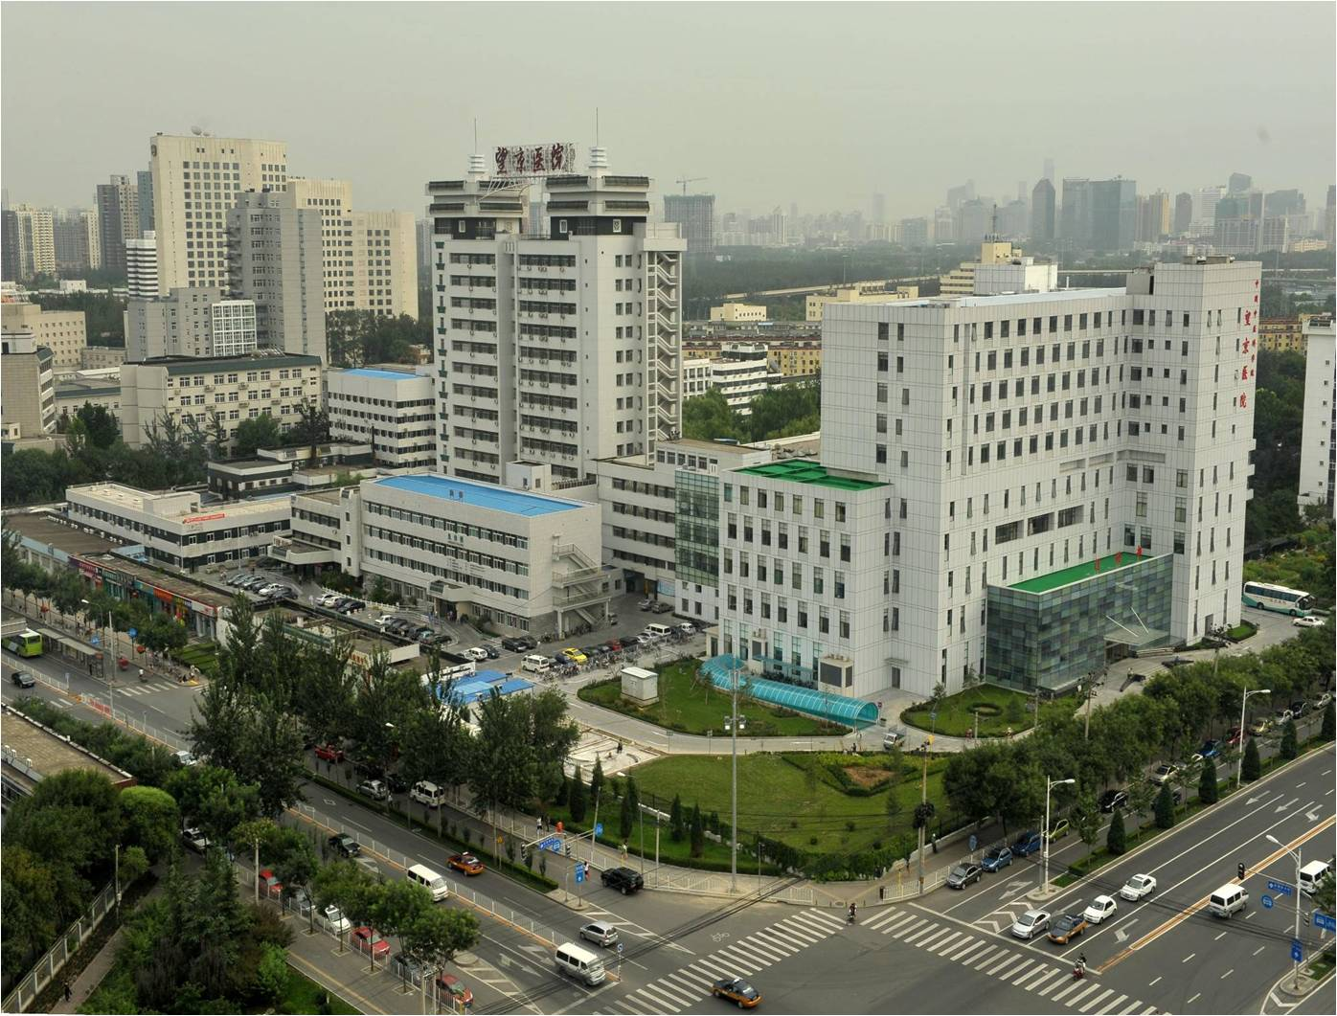
Wang Jing Hosp.-Affiliated Hosp.of the China Academy of Chinese Medical Sciences
the Website of Our TCM Oncology Department：http://wjtumor.com

